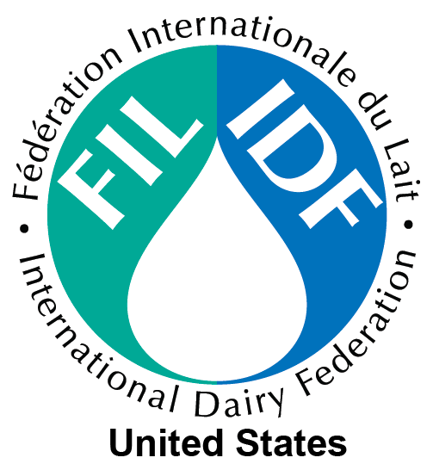

United States National Committee of the
International Dairy Federation
P.O. Box 930398
Verona, WI 53593
Tel 608-219-4115 ♦ Fax 608-262.1578
usidfsec@usidf.org

Membership Application

Organization _____________________________________________

Address ______________________________________________

City _____________________State_________Zip_________

Telephone _____________________Fax______________________

Key Contact _____________________Email____________________

Signature _____________________Date_____________________

Please indicate below the appropriate membership category. An explanation of each category may be found on the back of this application. Each membership level is based on gross annual receipts.

◆ Corporate Membership
Please make check payable to: US - IDF
Mail application and check to: US-IDF
P.O. Box 930398
Verona, WI 53593
To make payment electronically, please contact usidf@usidf.org.

__ Level I $2000 $0 million to $10 million
__ Level II $3500 $10 million to $100 million
__ Level III $5000 >$100 million

◆ Institutional Membership
__ Level I $2000 Federal Government
__ Level II $1000 State Government
__ Level III $2000 Academic Institutions

◆ Association Membership
__ Level I $4000 $0 - $5 million
__ Level II $7000 >$5 million

Debra Wendorf Boyke, National Secretary
US - IDF
P.O. Box 930398
Verona, WI 53593
Tel: 608.219.4115 * Email: dwboyke@usidf.org

Membership Information

Membership in US-IDF is open to any organization or individual involved in the U.S. dairy industry or interested in the purpose and objectives of US-IDF and IDF.

Annual Dues

Annual dues are based on three categories of membership.

Corporate
Corporations, cooperatives, partnerships, limited liability companies, and sole proprietors

Institutional
Universities, colleges, and government departments or agencies

Association
State, regional, national and international dairy product trade, scientific and/or promotion associations/organizations.

Summary of Member Privileges

- Participate in developing and representing US positions on key dairy issues.
- Attend all membership meetings of US-IDF and IDF.
- Access to technical documents, position papers, fact sheets, and other scientific information related to relevant dairy topics.
- Serve on the IDF and US-IDF Standing Committees and Task Forces as approved by the US-IDF Board of Directors.
- Eligible for election to the US-IDF Board of Directors.

